NASA Mini Moon Rover Payload

Project Deadline: 8 June 2020

# Problem Statement

**Goal:** Develop an idea for a very small payload module for mini lunar rovers to either

* Assist with locating resources on the moon, or
* Enable in-situ resource utilization (ISRU), or
* Enable lunar science (run relevant experiments or demonstrate new instrumentation that can work in a *lunar* environment)

**Relevance:** There are already many *ideas* for miniaturized payloads, but NASA is specifically looking for *practical* miniaturized payload ideas that would be reasonably ready for short term development.

# Scope

**Out of scope:**

* Expertise in the field of in-situ or remote sensors is not required :)

**Conditionally acceptable:**

* “Deployables can be allowed by agreement with program office”
* Developing a new resource identification method or technology from scratch rather than adapting existing tech or methods to be small and moon-ready
  + Try to avoid this for timeline reasons
  + But if we already have the research and knowledge needed to confidently design a new method, that’s more reasonable (i.e. if we know enough to feel confident that microfluidics could be useful in some way, for example)
* Payloads that require external data processing/analysis, like a trip back to Earth or a visit to a separate more advanced processing facility located on the moon
  + Payloads would need to be pretty valuable to be worth an entire trip back to Earth if the rovers weren’t already intended to return to Earth
  + Similarly, a payload that requires special additional equipment in a moon-based processing “facility” like a lander would need to be a pretty valuable idea to be worth taking up space with special equipment
  + Awaiting response from NASA or HeroX for exact clarification on whether this is in scope
* Payloads that we do not have the skills to develop if our idea wins
  + The “likelihood that proposer/proposing team can successfully develop proposed payload” is a factor in judging

**In scope:**

* Payloads that address one or more of the following broad strategic knowledge gaps:
  + **Lunar resource potential:**
    - Identifying resources in regoliths (especially water, carbon dioxide, methane, sulfur, or high concentrations of oxygen, carbon, titanium, and iron)
    - Availability of regoliths at lunar poles and how regolith density/availability varies with depth, cohesiveness, grain sizes, slopes, and blockiness
    - In-situ resource utilization and/or testing
  + **Lunar environment:**
    - Solar activity, like solar event prediction and warning
    - Radiation environment at the lunar surface
* Payloads that take existing technologies for prospecting for resources and miniaturize and repackage them, and tailor them for use on the Moon
* Payloads that actively run relevant experiments
* Payloads that demonstrate new technologies/instrumentation that can be used in a lunar environment
* Payloads that work together as a group for increased functionality

# 

# Relevant Figures and Diagrams

**Figure 1:** Approximate size of max geometry limits compared to a pack of Kraft Singles for visualization

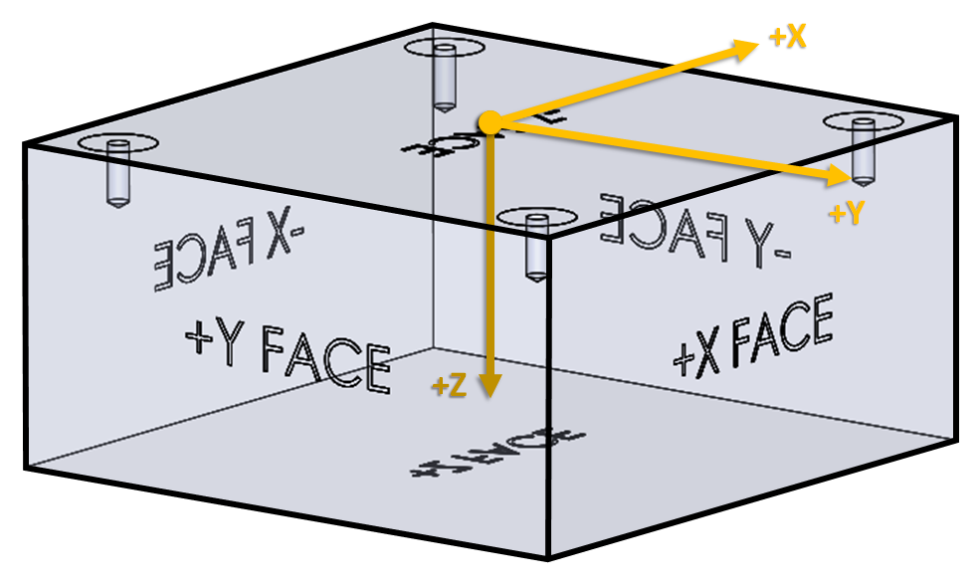

**Figure 2:** Orientation of payload with respect to spacecraft/rover coordinate system

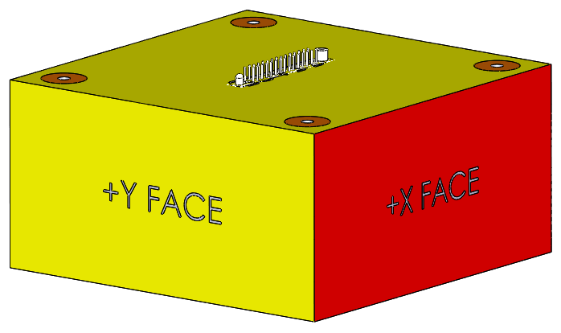

**Figure 3:** Bounding geometry with required connector in required location

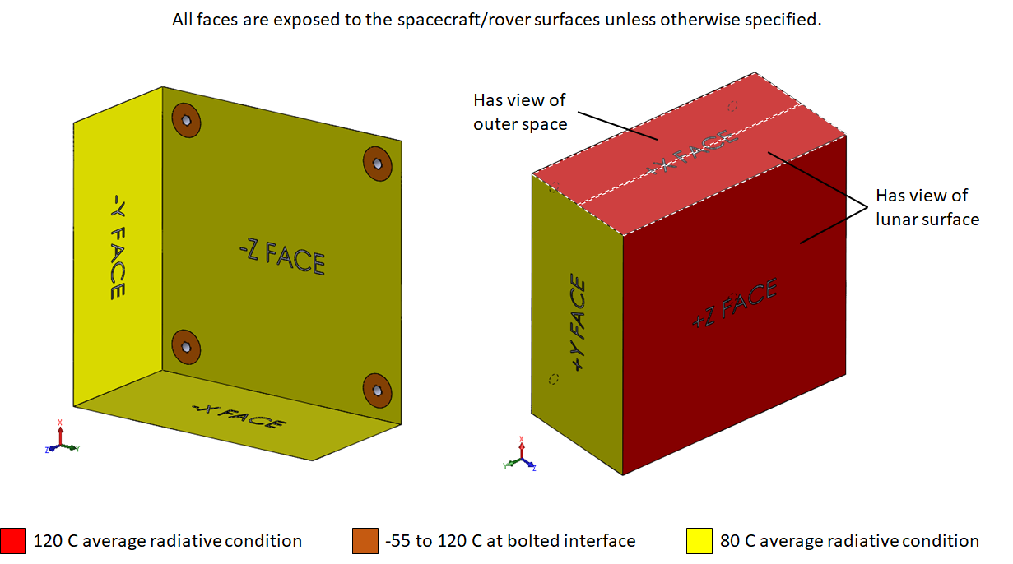

**Figure 4:** Radiative conditions of payload faces during rover operation

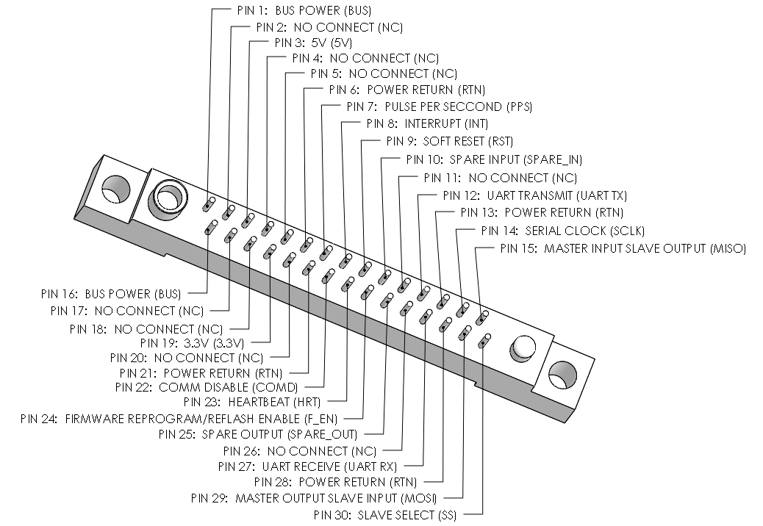

**Figure 5:** RM212-100-121-5500 required connector with rover pin-out labels

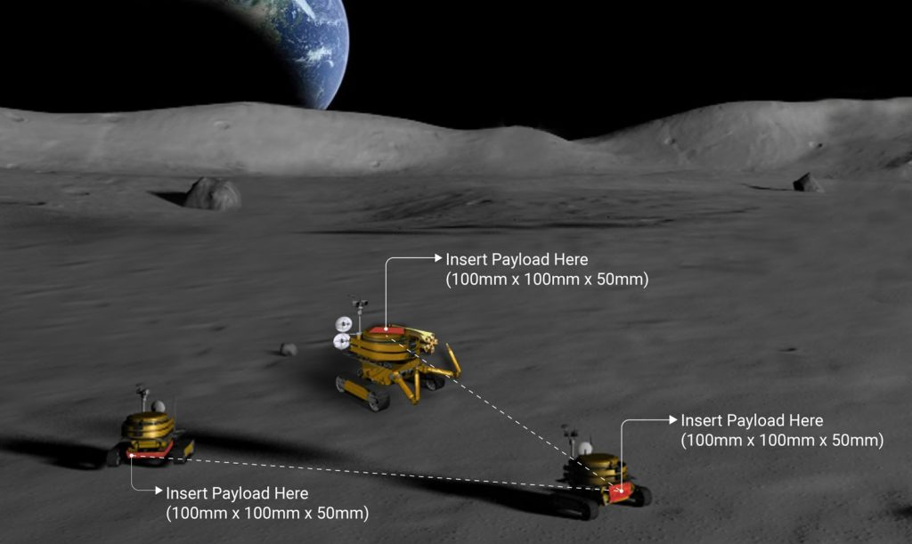

**Figure 6:** The lunar micro rovers have a number of options for payload locations

# Solution Needs

**Geometry and content requirements and restrictions:**

|  |  |
| --- | --- |
| 1. Must fit in micro rover payload compartment | |
|  | Maximum exterior enclosed dimensions of 100mm x 100mm x 50mm (refer to Figure 1 for size visualization) |
|  | Dimensions may be exceeded by maximum 0.8mm during dynamic loading (see function requirement 6) |
|  | Maximum mass 0.4kg |
|  | Refer to Figure 2 for orientation w.r.t. spacecraft/rover coordinates |
| 1. Must use a **RM212-100-121-5500** or **RM252-030-3XX-5500 AirBorn connector** to connect electronically to rover (see Figure 3 for pinout) | |
| 1. Cannot include “dangerous stored energy” at time of launch | |
|  | No charged batteries, supercapacitors, sealed pressure vessels of any type, or reactive chemicals |
| 1. Enclosed designs must include vent holes to mitigate launch pressure differentials | |

**Material requirements:**

|  |  |
| --- | --- |
| 1. Material requirements for interfacing surfaces between payload and rover/spacecraft must be specific materials | |
|  | Threads must be free from paint, anodize, or other non-conductive coatings |
|  | Threads must be conductively tied to payload chassis ground |
|  | Bearing surfaces between payload and rover around threads (orange patches in Figure 3) must be made of chemfilm, bare aluminum, electroless nickel, gold, anodize, stainless steel, titanium, or tiodize |
| 1. Cannot include forbidden materials | |
|  | No pure beryllium, cadmium, mercury, zinc, radioactive materials, or unalloyed or unencapsulated tin of greater than 90% purity |
| 1. Payload must be made of materials that minimally outgas in a vacuum (<https://www.aac-research.at/en/outgassing/>) | |
|  | Total mass loss (TML) <1% |
|  | Material Collected Volatile Condensable Material (CVCM) <0.1% (<http://blog.parker.com/why-is-outgassing-critical-in-optics-and-electronics-applications>) |
| 1. Coefficient of thermal expansion must match that of spacecraft/rover at connecting face | |
|  | Payload coefficient of thermal expansion at -Z face must be 20 to 25ppm/C (ppm/C unit is a 1 to 1 ratio to 10^-6/K unit)  Aluminum 6061 works. Stainless steel does not. |

**Function requirements:**

|  |  |
| --- | --- |
| 1. Withstand launch, flight, and lunar surface thermal conditions ranging from **-120 to +100 C** | |
|  | **Pre-Launch:** 0 to 27 C climate controlled conditions |
|  | **Launch:** -60 to +27 C, encapsulated in an “environmentally controlled payload fairing” |
|  | **Cruise:** -60 to +100 C, influenced by exposure to shadow or sunlight |
|  | **Lunar Orbit:** -120 to +100 C, influenced by exposure to shadow or sunlight |
|  | **Lunar Surface:** -30 to +80 C, influenced by exposure to shadow or sunlight during rover operation during lunar morning (not representative of lunar night conditions) |
|  | Refer to Figure 3 for average radiation boundary conditions (temperatures experienced at different faces) of the payload bounding box during rover operation |
| 1. Payload must mitigate potential dust hazards independently of spacecraft/rover | |
| 1. Withstand **Total Ionizing Dose of max 6krad** with 2.54mm aluminum shielding **for 1 year** mission length | |
| 1. Tolerate Solar Proton Flux, Solar Heavy Ion Flux, Galactic Cosmic Ray Proton Flux, Galactic Cosmic Ray Heavy Ion Flux | |
| 1. Withstand 100g (981 m/s2) static acceleration in X, Y, Z directions | |
| 1. Remain on Moon for up to one year of missions, each mission up to 3 lunar days long | |

**Electrical requirements:**

|  |  |
| --- | --- |
| 1. Large metallic components must be grounded to payload chassis | |
|  | Internal & external metallic components with **surface area >3cm2** |
|  | Internal & external **wires with length >25cm** |
| 1. Minimal resistance between primary payload electrical return and and spacecraft/rover primary return, and between payload chassis ground and spacecraft/rover chassis ground | |
|  | Resistance between primary electrical returns <=2.5mohm |
|  | Resistance between chassis grounds <=2.5mohm |
| 1. Payload must accept electromagnetic interference from spacecraft/rover transmitting at 900MHz and 2.4GHz frequencies | |
|  | If electromagnetic radiation (EMR) is needed for payload function, vent holes and connectors can serve as EMR apertures |
| 1. **Payload must tolerate immediate unanticipated power loss.** Payload will not receive power during launch, cruise, and launding, or during critical spacecraft/rover operations (such as mobility) | |

**Operational requirements:**

|  |  |
| --- | --- |
| 1. Any telecommunication must be transmitted through spacecraft/rover | |
| 1. Payload must include a “heartbeat” output function to simply communicate its status to the spacecraft/rover | |
| 1. Max continuous data rate from payload to spacecraft/rover limited to 1 to 2 kb/s | |

**Operational resources available:**

|  |  |
| --- | --- |
| 1. Nominal clearance between +Z payload face and lunar surface is ~6.5cm | |
|  | +Z face may be exposed to direct sunlight at max continuous elevation of 30 degrees |
|  | +Z face may be exposed to direct sunlight at max instantaneous elevation of 45 degrees during driving events |
| 1. Spacecraft/rover can deliver +X payload face within 5cm of targets that are taller than 6.5cm | |
|  | +X face may be exposed to direct, normal sunlight |
| 1. Primary bus power availability provided from spacecraft/rover will be current-limited and switched, and will include any of these options as is desirable | |
|  | 6-8V |
|  | 8V, 1A MAX, 50ms MAX |
|  | 4W, 0.5A continuous |
| 1. Spacecraft/rover provides current-limited and switched regulated secondary rails | |
|  | 3.3V, 100mA MAX |
|  | 5V, 100mA MAX |
| 1. Spacecraft/rover provides primary bus return and ties all grounds/returns to primary bus return | |
| 1. Spacecraft/rover will not store data | |
| 1. Spacecraft/rover will use “heartbeat” detected through Pin 23 to sense payload | |
|  | Spacecraft/rover will soft reset payload through Pin 9 if no heartbeat received for 5 continuous seconds |
|  | Spacecraft/rover will power cycle payload if 5 consecutive soft resets fail |
|  | Spacecraft/rover will turn off payload permanently if 2 consecutive power cycles fail |
| 1. Asynchronous UART TX/RX provided by spacecraft/rover at 115kbaud/sec | |
| 1. One SPI master provided by spacecraft/rover at 1Mbits/sec | |
| 1. Payload can query spacecraft/rover telemetry | |
|  | 6-axis inertial measurement unit (IMU) data |
|  | UTC (or equivalent global) timestamp |
|  | Bulk temperature data |
|  | Odometry (change in position over time) |
|  | Estimated position and orientation |

**Other requirements:**

|  |  |
| --- | --- |
| 1. Competition submission requirements | |
|  | Payload overview (3000 characters max) |
|  | Payload capabilities: what it consists of, what it does, why it’s important, how capabilities relate to bridging knowledge gaps (3000 characters max) |
|  | Payload technical maturity discussion (3000 characters max) |
|  | Project plan for theoretically moving forward with implementation (3000 characters max) |
|  | Compliance with Small Lunar Payload User’s Guide requirements: If any valuable ideas need to deviate from these requirements (summarized here, adapted from the guide), must have reasonable explanation for why deviation is important/unavoidable, plus propose possible mitigation strategies (3000 characters max) |

# 

# Important dates

**Submission deadline:** Monday, 8 June 2020, 2pm PST

|  |  |  |  |  |  |  |
| --- | --- | --- | --- | --- | --- | --- |
| **SUN** | **MON** | **TUES** | **WEDS** | **THURS** | **FRI** | **SAT** |
| 12 Apr | 13 | 14 | **15:** Begin research | 16 | 17 | 18 |
| 19 | 20 | 21 | 22 | 23 | 24 | 25 |
| 26 | 27 | 28 | 29 | 30 | **1 May:**  Finish research | 2 |
| **3:**  Finish brainstorming | **4:**  Finish idea selection, begin technical development | 5 | 6 | 7 | 8 | 9 |
| 10 | 11 | 12 | 13 | 14 | 15 | 16 |
| 17 | 18 | 19 | 20 | 21 | 22 | 23 |
| 24 | 25 | 26 | 27 | 28 | 29 | 30 |
| 31 | **1 June:**  Finish design, begin write up | 2 | 3 | 4 | 5 | 6 |
| 7 | **8:**  Submission deadline |  |  |  |  |  |

# Timeline Estimate

1. ~~Familiarization with challenge~~

* ~~Review guidelines, rules, restrictions, etc.~~

1. ~~Research and familiarization with relevant methods: complete by~~ **~~1 May~~**
2. ~~Idea brainstorming and conglomeration: complete by~~ **~~3 May~~**
3. ~~Ranking and selection of ideas: do on~~ **~~3 May~~**

* ~~Ranking with respect to both “coolness” and “implementability”~~

1. ~~Technical development of selected idea(s): start by~~ **~~4 May~~**

* ~~Acceptable to start this phase with a few equally strong ideas and reduce them down to one idea based on difficulty of implementation as development progresses~~

1. Design finalization and submission prep: start by soft **1 June**, hard 5 June

* Technical writeup and whatnot per “other requirements” section above
* Timeline plan for theoretical actual development of project if we were to win

# Budget Estimate

Zero (challenge only requires an idea)

# Relevant Links

Competition summary: <https://www.herox.com/NASApayload>

Small Lunar Payload User’s Guide: <https://d253pvgap36xx8.cloudfront.net/challenges/resources/74a421d479b811ea982a0eec503993af/Small_Lunar_Payload_Users_Guide.pdf>

Payload instruments being developed by contracted companies external to this competition but related to the overarching NASA project: <https://www.nasa.gov/press-release/nasa-awards-contract-to-deliver-science-tech-to-moon-ahead-of-human-missions>